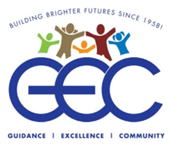

June, 2022

Name
Address
City State Zip

Dear _____________________

Greetings and happy summer to all of our very good friends of the GEC! Last year, when I was writing our 2021 spring appeal letter, the focus was on hope…emerging from the darkness brought on by the pandemic and hoping for brighter times, and maybe a return to some sense of normalcy. It’s taking a bit longer than we all would have liked, but I believe we are getting there.

This year, I would like to turn our attention to a close relative of hope…faith.

“Faith is taking the first step, even when you don’t see the whole staircase.”
-Dr. Martin Luther King Jr.

I was reminded recently, by someone very wise, that the parents of a child with a developmental disability survive on hope and faith; hope, that they will be able to build a good and happy life for their child; and faith, that they will find a community that is compassionate, and that recognizes the value of each person as an extraordinary individual.
The Guild for Exceptional Children has been providing compassionate, individualized care and support to children and adults with developmental disabilities for 64 years, and admittedly we still don’t see the whole staircase. We are always ready, however to take the next step. We are able to do that because we have faith; faith that serving people in need is always the right thing to do; faith in the dedicated staff who put the individuals we serve ahead of themselves; faith in each other. And despite the challenges we face, we never allow ourselves to take for granted the faith that families have placed in us.
This year we have taken some steps forward:
We made sure that all of the people in our care are safe and fully vaccinated.
We incentivized our dwindling workforce to do the same.
We re-opened our day habilitation programs and returned to in-person services at our school.
We returned to voluntary worksites in the community for our program participants and with the help of our Bay Ridge community partners. This has been very important for the self-esteem and independence of our participants.
We are piloting an Autism Awareness Initiative to help introduce parents of young adults with autism to the array of City & State funded services available to them.
We started up our after-hours Recreation program in person again.
We began the journey of (carefully) re-opening greatly missed social gatherings. I cannot stress how important recreation and socialization are for this population, especially considering the extended isolation that came from the pandemic.
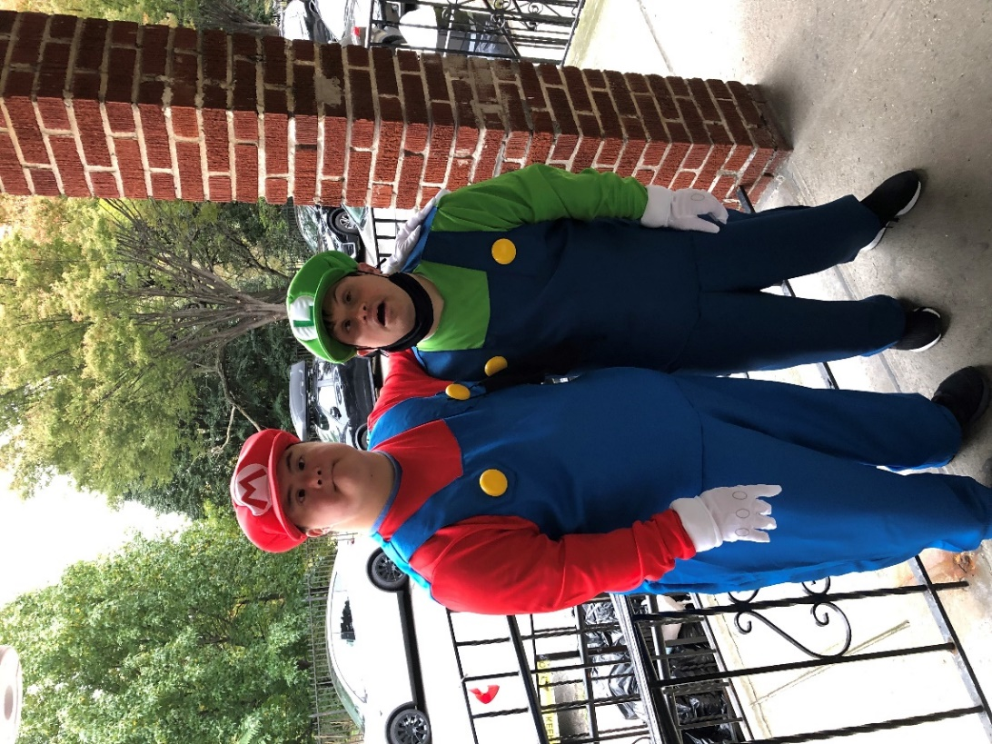
Below you will see just a few photos of some of the many happy moments enjoyed by GEC participants this past season.
Lawrence and Michael, two close friends who reside at GEC’s Conklin Residence, dress up as two famous brothers for a costume party.
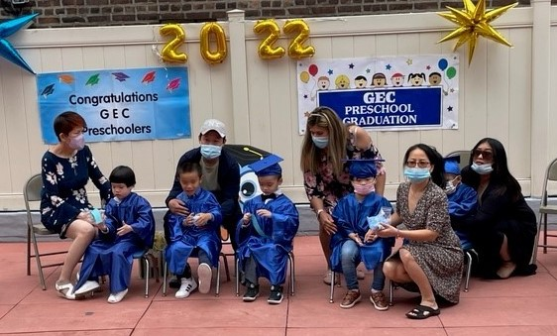
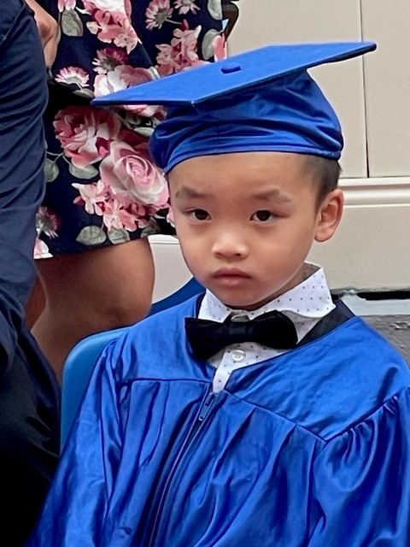
Excited preschoolers attend graduation ceremonies at GEC’s Carrie Mastronardi Early Childhood Center.

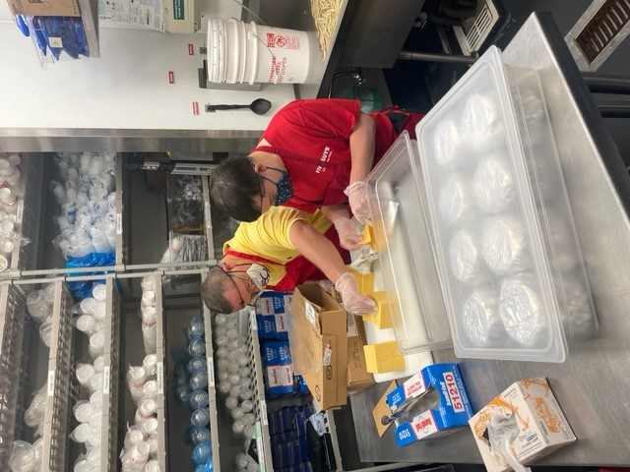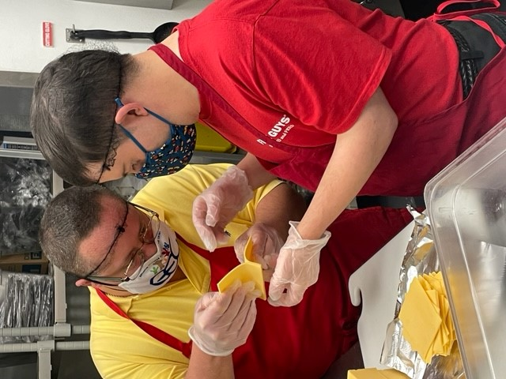
Day Habilitation Without Walls Participants happily return to volunteer at community work sites such as Five Guys Burgers (above) and Skinflints restaurant (below).
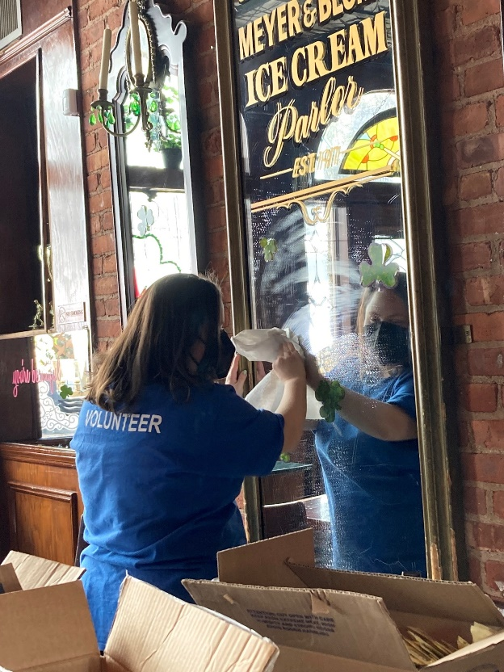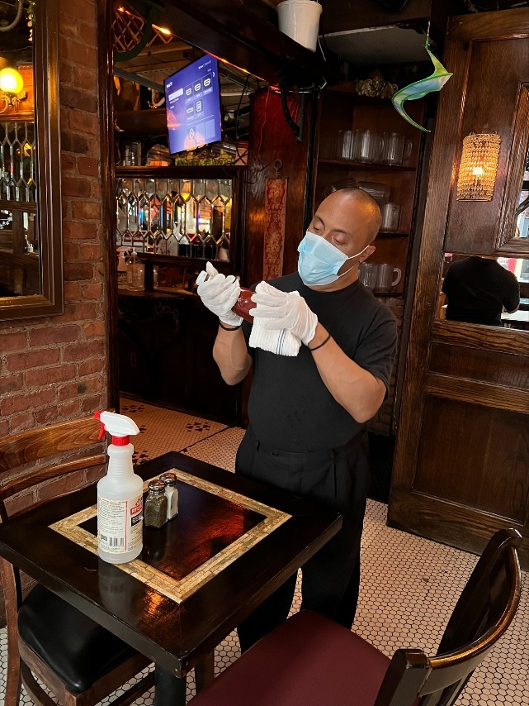

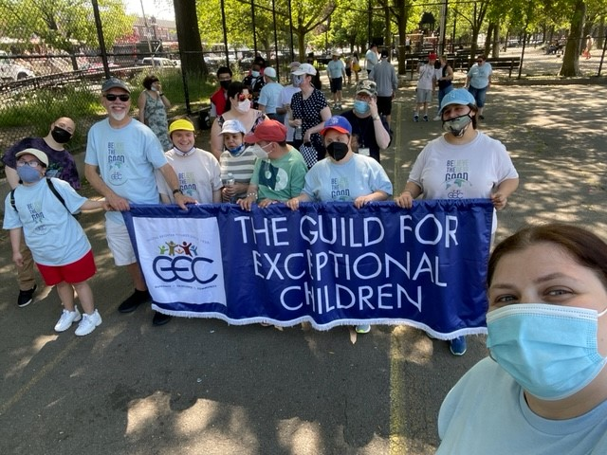
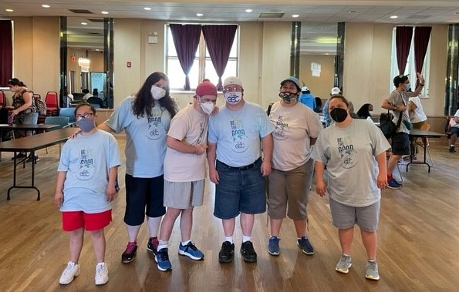
GEC participants, staff, and families participate in our annual 5K fun run/1 mile walk.

The GEC is ready to take next steps forward and, as usual, we need the help of you, our loyal friends and supporters. This year some of the things we would like to do include:
- Expand our community work sites and enable more of the individuals we serve get a feeling of accomplishment and independence by volunteering in the community;
- Re-establish our day program in the Marine Park area (closed since COVID);
- Refurbish our aging IT infrastructure to protect the sensitive data of the people in our care;
- Establish a funding steam to help with the costs of providing bedside care & advocacy to people with developmental disabilities who are in the hospital or hospice;
- Refurbish our greenhouse and re-establish a thriving horticultural program;
- Enhance transportation by replacing some seriously aging vehicles and hiring more drivers;
- Develop an active incentive program for our staff to keep our workforce strong and growing;
- Enhance our Preschool Services and bring teacher and professional salaries in line with the City so that we can serve more children in need.
GEC is ready to take the next step, to boldly go…but without seeing the entire staircase this will require, as so many things do, a leap of faith. We have good reasons to take that leap, including a proud history (since 1958) of providing quality care and services to people with developmental disabilities while actively serving the community. We take that leap secure in the knowledge that the community supports us, our friends and families support us, and that we have extraordinary, dedicated staff. We take the leap because it is absolutely the right thing to do!
I sincerely hope that you will find it in your heart to continue to support GEC and our mission of care!
I have faith that you will do what you can!
“True faith is not a leap into the dark; it’s a leap into the light”
-Eric Metaxas
Perhaps we can take that leap together!

Sincerely.

Joseph L. Riley
CEO/Executive Director
The Guild for Exceptional Children
260 68th Street Brooklyn, NY 11220
(718)833-6633x211
JRiley@gecbklyn.org

