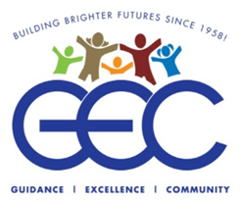

April, 2021

I would like to start by saying thank you for being such a good friend of GEC!
Spring is upon us, and with it, a sense of renewal. We see signs of life all around us as trees bud, flowers bloom, and birds sing. It has been a long and hard winter for many of us, still trying to break free from pandemic fears and restrictions, but with the spring comes a different perspective, a brighter attitude, and something else that is sorely needed: a glimmer of hope. We have all heard or seen inspirational quotes about the importance of hope. One of my favorites came from “Superman” himself, the late Christopher Reeve who, despite his crippling accident, said, “Once you choose hope, anything’s possible”.
At the Guild for Exceptional Children (GEC) we choose hope. GEC remains steadfast in keeping our mission of care strong during these difficult and unprecedented times. We are sincerely grateful to our loyal donors for lending their financial support to help us manage the unexpected expenses incurred from COVID 19.
Throughout this crisis our main objective has been to keep all of our program participants, and staff protected and safe. We have witnessed hundreds of times the dedication of our Direct Support Professionals, Preschool Faculty, and all GEC Management, Professional, and Administrative Staff in caring for the children and adults in our programs and residences.
When asking around for some stories to share with you I hit upon some recurring themes:
- How staff volunteered immediately and consistently during the crisis;
- How the exhausted staff, managers, supervisors, and educators tried to brighten every day with a positive attitude and a different theme for the day;
- How virtual supports at both the Preschool and Adult Day Programs, helped individuals to be actively engaged throughout the crisis;
- How families donated or bought meals, desserts, and supplies for the programs;
- How people in our community donated, food, cleaning supplies and PPE;
- How the entire Guild helped one another out - checking on each other and caring;
- How there was no shortage of prayers offered for people who had fallen ill.

I would like to share with you a couple of specific examples that illustrate how “Hope springs eternal,” at the GEC.
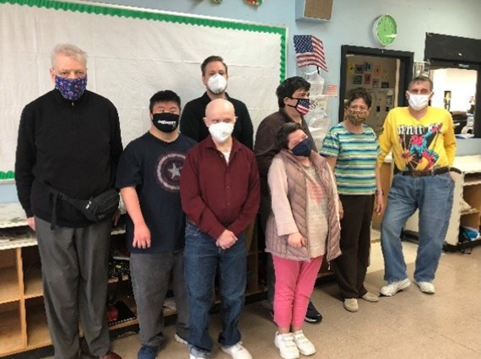
John Thompson, one of our day program supervisors, is a dedicated, creative, hands on gentleman. He is humble and will probably be mortified that he is mentioned here, but he is worth mentioning. John loves the work he does and truly cares for the individuals in his program; even the ones who can no longer attend. John, like our other program supervisors, runs in person day services at the Mastronardi program, as well as conducting virtual sessions on ZOOM. This often becomes a 10 or 12 hour day. He doesn’t want to leave anyone out. John’s dedication goes beyond those duties however. For many years a gentleman we shall call “Angelo” attended the Mastronardi program. Angelo and John become close. When Angelo’s mother passed away several years ago, he became withdrawn (agoraphobic) and will not leave his house. Long before COVID, he withdrew from the program. John never forgot his friend, even though he is no longer John’s responsibility. Or is he? John calls and visits his friend regularly, offering hope to Angelo’s family, that he will once again be willing to venture out and join his friends at GEC. We should all have that sense of responsibility, and a friend, like John.
John with some of the participants at Mastronardi Day Habilitation
“Jim” is a charming and gentle man of about seventy who has been served by GEC for some 40 years. For most of that time Jim was very independent, working and socializing with his friends and family and caring for his pets in one of our supportive apartments. In recent years Jim has been battling some serious conditions, and during the height of the COVID pandemic, was waging a war on cancer. Throughout most of this past year he has been either in the hospital, or in a rehabilitation facility recovering from cancer treatments. During that entire time his manager, Anthony Martinez, never gave up on Jim, visiting him nearly every day, coordinating his care, and boosting his spirits. Anthony, and more importantly Jim, chose hope. Despite spending so much time in medical facilities during this very risky period, by some miracle Jim never caught COVID, and has just been discharged from rehab and moved into our Conklin Residence, back in the care of GEC, and on the road to recovery…anything is possible.
Anthony advocating for our services

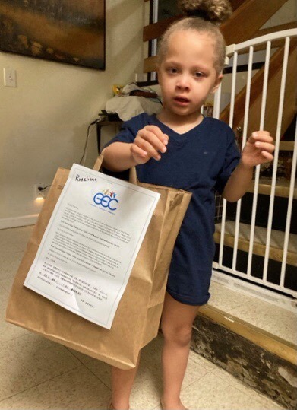
Each year, GEC uses IDEA money to support an arts program for GEC’s preschoolers. Through this program an art instructor provides lessons that support our preschoolers in achieving individual education plan (IEP goals). This past year, during a very different school year, many lessons were provided virtually to students. To support this work this spring, our preschool staff stuffed bags with art materials such as construction paper, wiggly eyes and feathers to be delivered to our students homes. Lots of smiling faces were happy to get the materials to further support the art lessons. It takes many hands and community support at the state level as well as the federal level to create school opportunities for students with differing abilities. We all rise as we support each other.

A child happily receiving art supplies from our Preschool

Sandy Rivera is a Direct Support Professional (DSP) who works at our Santangelo Residence. When COVID hit last spring, like so many others she volunteered to “shelter in place” with the residents at Santangelo. This was an agreement staff made to work seven days and nights straight, without leaving. During those early days COVID hit that house hard, and Sandy lost James, an individual she considered a close friend. That only strengthened Sandy’s resolve. She worked the next seven (7) consecutive weeks to care for the people at Santangelo. The kicker is that she was newly married at the start of the pandemic. She delayed her honeymoon to take care of her family at Santangelo. You don’t see that kind of devotion every day, and it certainly gives me hope that there are some truly good people in the world, and here at GEC!
Sandy with some of her friends at Santangelo Residence

The Guild for Exceptional Children is facing some very big challenges ahead.
- Like the individuals we serve, many of our staff, including senior management, have been ravaged by COVID. Vacancies have to be filled in our programs, our residences, and staff have to be hired and trained.
- We’ve arranged to have hundreds of our participants and staff vaccinated but there are many others, who have so far been unable or reluctant to get the vaccine. We are doing everything we can to make it available to them, and provide education and encouragement.
- We have been working on improving our existing space, installing room dividers and ventilators, and arranging for hydrostatic deep cleaning, but there is more to be done.
- We are looking for ways to expand our usable space, including renting space, so that we can bring more people back to program while keeping in line with social distancing mandates.
- We are trying to acquire more vehicles and drivers to safely transport individuals without violating vehicle capacity mandates set by the pandemic.
- We need to update our IT and communications platforms to position GEC to be better able to reach individuals and their families who need support.
Despite a generous stimulus package generated by the Federal Government, there are, unbelievably, still plans for cuts in NYS to some of our funding. In particular cuts to residential services are planned, and funding for special educations schools is always in jeopardy. We, here at GEC have been fortunate; fortunate to have the support of friends and family like you to help get through the difficult times, and despite everything, to grow and improve. It is time to recover from the weight of the pandemic and rebuild. Please consider helping us to REBUILD THE GUILD! The needs I have outlined above may be costly, but they are also vital to this effort. Please consider helping us in this effort. If you can, I’d like you to think about making a recurring contribution (weekly, monthly, annually) whatever you are comfortable with. Know that every contribution will help us to rebuild! We also have opportunities for “honorariums” where people can be honored or remembered permanently on our “Tree of Life”.
We live in a society which has become bitterly divided. Unfortunately there is no shortage these days of negative rhetoric, decrying this group or that point of view. It is nice to be part of cohesive group, where we support each other; a group that has been “Building Better Lives Since 1958”. The Guild for Exceptional Children has one agenda: to help children and adults with developmental disabilities lead fuller and happier lives. With the help of our friends and supporters like you, we hope to do this for years to come. We choose hope, so anything is possible!
I hope that you and your families have a safe, happy, and hopeful summer!

Sincerely,
Joseph L. Riley
Executive Director/CEO

